ALCA Graduate Student  Poster Session  Sponsored by Bradford Health Services  November 17-19, 2021  Birmingham, Alabama  The ALCA Graduate Student Committee is pleased to coordinate the annual Graduate Student Poster Session. The poster session is an excellent opportunity to recognize the outstanding work of our students. The session will be held on Thursday, November 18, 2021, from 1:30 pm – 3:30 pm. Please submit proposals via e-mail no later Friday, September 17, 2021.  The session can feature original research, literature reviews and projects that reflect innovative and/or unique contributions to knowledge pertaining to training, treatment, assessment, or theory in the field of counseling. The information can be mounted as a poster that will be displayed on a table or easel. The content on the poster should allow for ease of reading. The student will not make a formal presentation but will stand with the poster and interact with participants individually. Each student should bring at least 50 handouts that capture the essence of the information on his/her poster, including references.  Accepted poster session proposals will be notified by Friday, September 24, 2021; students who participate must be a member of ALCA and register for the conference  In addition to completing this form, please submit the following (separate word document):  - Title of proposal  - Poster description (not to exceed 45 words)  - One learning objective  - Three relevant peer reviewed journal articles (APA format) | NOTE: ALL PRESENTERS MUST BE REGISTERED  FOR THE ANNUAL CONFERENCE  --------------------------------------------------------------------------------------  Please use the form and format below. Please be sure that all information requested on the proposal form is accurate and submitted as an MSWord document; no PDF files.  PROPOSAL DUE DATE: Friday, September 17, 2021  Contact Presenter:  Student Level: ____Master's ____EdS ____Doctoral (check one)  Address:  City/St/Zip:  Email:  Phone:  University:  Assisting Faculty Member:  Presenter:  Student Level: ____Master's ____EdS ____Doctoral (check one)  Address:  City/St/Zip:  Email:  Phone:  Presenter:  Student Level: ____Master's ____EdS ____Doctoral (check one)  Address:  City/St/Zip:  Email:  Phone:  Presenter:  Student Level: ____Master's ____EdS ____Doctoral (check one)  Address:  City/St/Zip:  Email:  Phone:  All information must be typed (font size no larger than 11) and should be emailed to Dr. Latonya Graham at - dr.lmgraham@gmail.com  Questions: Please Contact Graduate Student Co-Chair  Dr. Latonya Graham (dr.lmgraham@gmail.com)  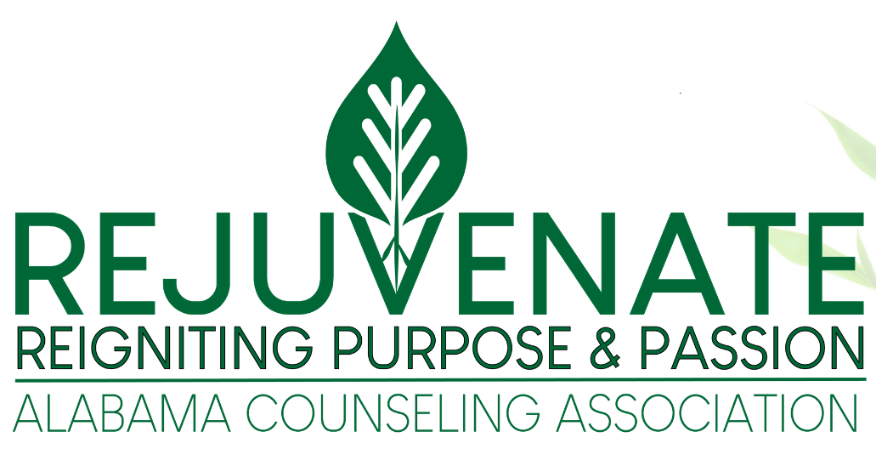

Upon submission of this poster session proposal, you are acknowledging your obligation to abide by the ACA Code of Ethics. Further, you are accepting the responsibility to ensure that all information provided in your presentation, including the words and actions of yourself and your co-presenters reflect and uphold the ACA Code of Ethics. www.counseling.org/ethics

Alabama Counseling Association
2021 Graduate Student Poster Session Page – 2

Title of Poster Proposal
Poster Description (not to exceed 45 words)
One Learning Objective
Three Relevant Peer Reviewed Journal Articles
(APA Format)*

*APA Format:
Christian, D., Lawrence, A., & Dampman, N. (2017). Increasing college access through the implementation of
Naviance: An exploratory study. Journal of College Access, 3(2), 28-44.

